Jinku Jung
IT 2351
Professor Lizanich
April 29th, 2026
Module 6
- Question: “Explain the type of information stored in the general log file. What is the process to view this file?”

Answer: A general log by definition is a text file that contains a record of client connections, SQL statements received from the clients, and other information. To view a general log file, the process to view this file is:

- Enable logging options in the server configuration file:
general_log
-- Enable general log with a default name of HOSTNAME.log.
general_log_file = "/murach/mysql/general.log"
-- Specifies the name of the general log file.
b.) Configure logging
-- Store the output of the general and slow query logs in a table:
log_output = TABLE
-- Log errors, warnings, and informational messages:
log_error_verbosity = 3
-- Delete binary log files that are more than 7 days old:
expire_logs_days = 7
-- Set the maximum binary log file size to 1MB:
max_binlog_size = 1048576
-- Write queries to the slow query log if they take longer than 5 seconds: long_query_time = 5

c.) Viewing a general log file when they are already written to a table:
SELECT *, CHAR(argument) AS argument_text
FROM mysql.general_log
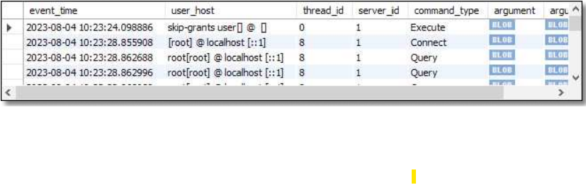

- Question: “What is the difference between status and system variables and, how are they viewed? Pick a system variable and explain its function.”

Answer: A status variable is a variable that contains information about the status of the MySQL server that can be dynamic (READ: CHANGE) during its runtime.

To view a status variable, enter the SQL statement “SHOW STATUS” in a query window.
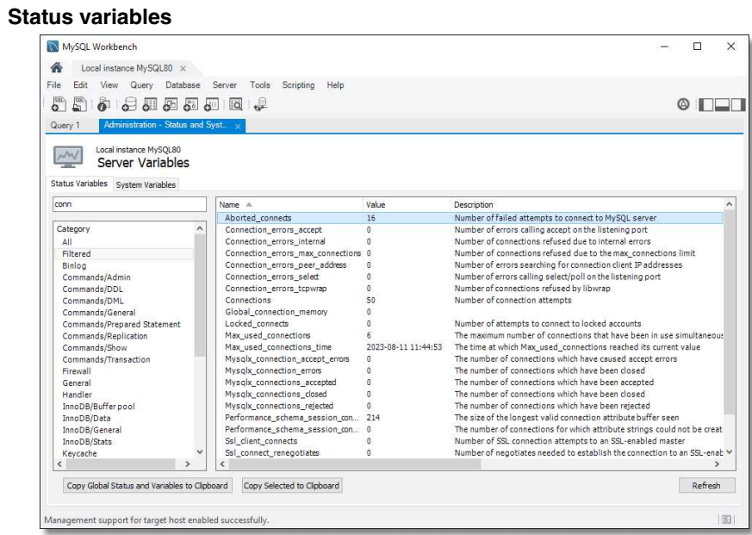

A system variable is a variable that stores a setting for the current configuration of the MySQL server (READ: IS USUALLY SET FROM A SAVED CONFIGURATION FILE BEFORE SERVER STARTUP).

To view a system variable, enter the SQL statement “SHOW VARIABLES” in a query window.

A known system variable is “basedir”—it specifies the path of the installation directory.

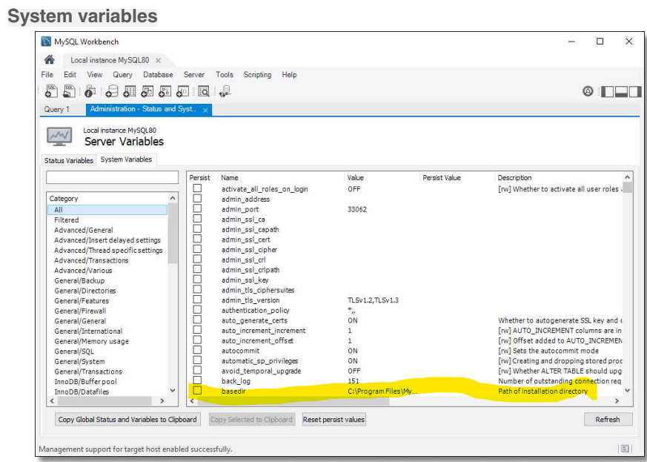

- Question: “Explain the concept of privileges and describe an example of a role and what privileges might be assigned to that role in the database of a small business.”

Answer: Privileges are database user permissions defined from a Database Administrator for a specific type of user: other administrators or users. User permissions are usually determined by user roles according to role based access control (RBAC) privilege-based delineation of user access control.

a.) Create the role: end user invoice entry: invoice_entry.
Command: CREATE ROLE invoice_entry.

- Sample privileges granted: INSERT, UPDATE
Commands: GRANT INSERT, UPDATE ON invoices TO invoice_entry
GRANT INSERT, UPDATE ON invoice_line_items TO invoice_entry

- Sample users granted such privileges: Jack and Jill.
Commands: GRANT invoice_entry TO jack, jill

- Verify privileges for a role already defined:
Command: SHOW GRANTS FOR invoice_entry

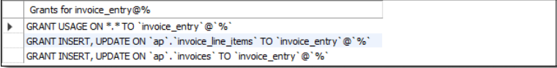

<Using your Jung_Guitar_Shop database for Questions 4 and 5…>

- Question: “Write the code to create a user "Jamie" who will need to update their password and cannot use a password that was used in their last 10 passwords.”

Answer:
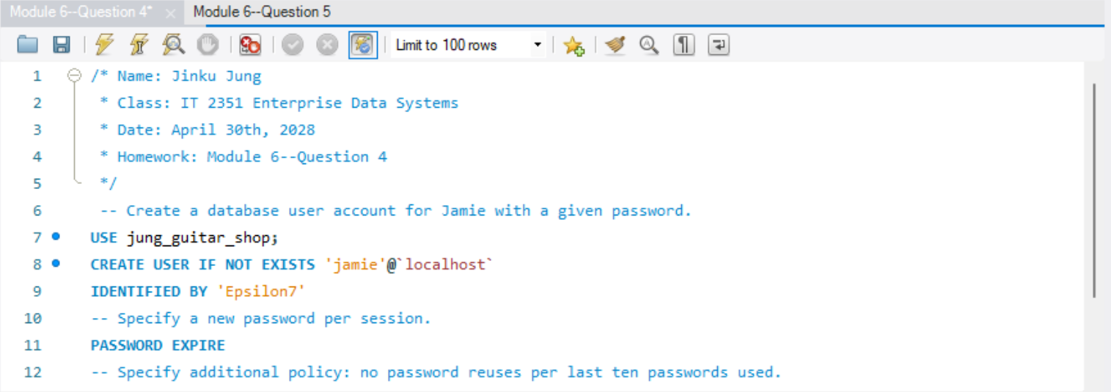
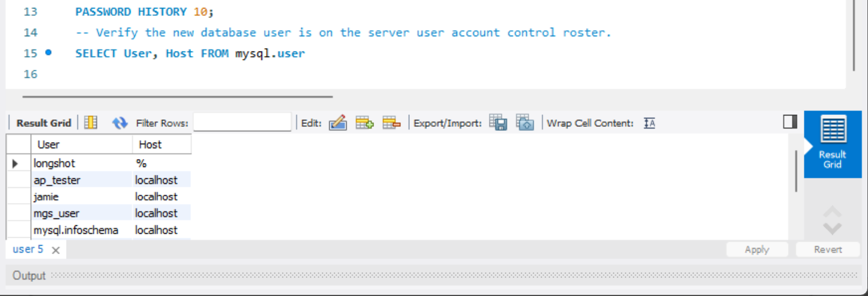

- Question: “Write the code to create a role called update_orders that has the privileges to insert and update the orders and order_items tables. Add “Jamie” from the previous task to this role.”

Answer:
